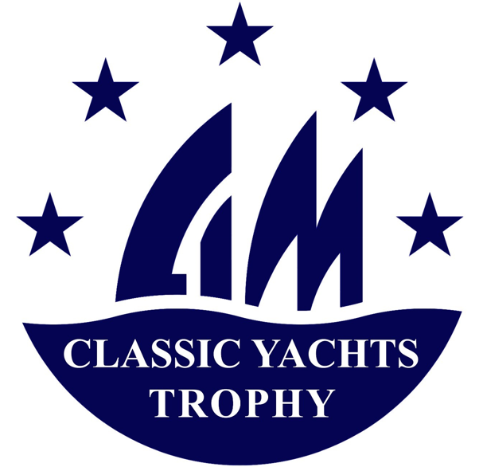

**CIM – CLASSIC YACHT TROPHY – 2025**

**Notice**

**1 - ORGANISING AUTHORITY**

The Organising Authority of the CIM CLASSIC YACHT TROPHY 2025 (the TROPHY) is the COMITE INTERNATIONAL DE LA MEDITERRANEE (CIM) in cooperation with the Organising Authorities (AOs) of each event included in the TROPHY.

**2 – RULES**

The rules applicable in the TROPHY are:

* Current Sailing Racing Rules
* The CIM Regulations for the Measurement and racing for Vintage and Classic Yacht 2022 -2025 and the amendments in force.
* Notices of Race and Sailing Instructions for each event
* The national regulations published by the Federations of the country where the event takes place.

**3 – ADVERTISING**

3.1 Competitors must give priority to the publicity provided by the IMC and/or the AO of the event in which they are participating.

3.2 Competitors will be able to display their advertising provided that:

* This is not in competition with those provided by the CIM and/or the AO of the event in which they participate, whose express authorization must in any case be obtained before posting it.
* Be in compliance with Article 20 of the WORLD SAILING regulations regarding Advertising.

**4 – ELIGIBILITY AND REGISTRATION**

4.1 The CIM 2025 TROPHY is open to Yachts with a valid CIM certificate, registration for each event is the responsibility of the competitor, in connection with and with the constraints of each organizer.

4.2 Each boat participating in the TROPHY will be assigned to one of the 5 classes as defined in the CIM regulations in force recalled below, regardless of the category in which it can be entered in each of the events in which it participates, taking into account the grids for the different events and the possible differences in subdivisions into categories.

Reference classes:

* + **Big Boats**: vintage CIM yachts (cf. article 2 of the CIM regulations) launched before 1950, and associated replicas, whose length is more than 24 meters - with length retained = average of the total length and hull length: (La+Lt)/2,
  + **Gaff Vintage**: other yachts from the CIM vintage (see article 2 of the CIM regulations) launched before 1950 with gaff rigging, and associated replicas
  + **Marconi Vintage**: other CIM vintage yachts (see article 2 of the CIM regulations) launched before 1950 with Bermudian rigging, and associated replicas
  + **Classic**: CIM Classic yachts (see article 3 of the CIM regulations) launched between 1950 and 1975, and associated replicas, not eligible for "Classic IOR"
  + **"Classic IOR":** Yachts launched between 1970 and 1984 (including with composite hulls), with an IOR certificate at the time, without modification and with the configuration of the time, with a CIM measurement certificate bearing the mention "Classic IOR" (see amendment n°4 of the CIM Measurement Regulations 2022-2025)

4.3 Class Pavilions and Racing Flames

Each class is identified by the wearing of a class flag presented in the appendix, possibly supplemented by a secondary flame in case of separation into subcategories.

4.4 There is no registration fee.

**5 – PROGRAMME**

Ten selected events in IMC countries: Spain, France, Italy, and Monaco with the following events:

Spain

Puig regatta (Barcelona) : July 9 – 12

Vela Clasica Mallorca (Palma) : August 13 – 17

Vela Clasica Menorca (Mahón) : August 26 – 30

France

Voiles d'Antibes: June 4 – 8

Régates Royales (Cannes): September 22 – 27

Voiles de Saint-Tropez: September 29 – October 4

Italy

Grandi Regate Internazionali (San Remo) May 28 – 31

Argentario Sailing week: June 18 – 22

Vele d’Epoca ad Imperia: September 2 – 6

Monaco

Monaco Classic Week September 10 – 14

**6 – RANKING**

6.1 Boats will be required to participate and be placed in at least one of the **3 events in 2 different countries** to be able to claim the CIM TROPHY ranking. DNS and DNC will not be taken into account in the TROPHY Ranking.  
Only **5 best results** will be taken into account if you participate in more than 5 events.

6.2 for each of the TROPHY events, the final general ranking of the event will be recorded, and the number of associated points will be calculated (progressive point system according to the place and number of participants in the category for the event). The ranking will be calculated based on the addition of all points earned from participating in TROPHY events.

6.3 **Event-based point allocation system**:

P: final place in the overall category ranking for the event

N: number of participants in the overall category ranking for the event

Number of points = 100 (N – P + 1) + 50 Log(N/P)



*Note: the "Class" system of the TROPHY is based on progressive points, taking into account the number of effective participants in the categories in the different events, allows performance to be valued according to the number of participants (winning with 15 participants is more valued than with 3 participants).*

6.4 In the event of a tie, Annex A8 of the RCV will apply

**7 – DATA PROTECTION**

8.1 Right to image and appearance

By participating in this competition, the competitor and his/her legal representatives authorize the CIM and the AOs of each event that is part of this TROPHY to use his/her image and name free of charge, to show at any time (before, during and after the competition) moving or static photos, films or television recordings, and other reproductions of themselves taken during the competition, on any medium and for any use related to the promotion of their activities.

8.2 Use of participants' personal data

By participating in this competition, the competitor and his/her legal representatives consent and authorize the CIM and the AOs of each event to use and store their personal data. This data may be published

**8 – PRIZES**

8.1 the 1st of each Class will be declared "Winner of the CIM Trophy 2025 – [class]"

8.2 The award ceremony will be organized [----------------]

**9 – RACE TRACKING AND RECORDING**

9.1 the follow-up of the races will be carried out via the Estela system (cf [www.estela.co](http://www.estela.co) )

9.2 participants will have to follow the protocol requested by the CIM to monitor and record the races

Image that contains text, screenshot, monitor, screen

Auto-generated description

**10 – CONTACT and ADDITIONAL INFORMATION**

Website: [International Committee of the Mediterranean (cim-classicyachts.org)](http://cim-classicyachts.org/fr/)

Email: [contact-cim@cim-classicyachts.org](mailto:contact-cim@cim-classicyachts.org)

**APPENDIX: CIM Class Flags**

Note: in the event of a sub-category separation, a secondary race flame may be provided by the organizer

Image containing logo

Auto-generated description

Image containing logo

Auto-generated description

Image containing logo

Auto-generated description

Image containing logo

Auto-generated description

**BIG BOAT**

**GAFF VINTAGE**

**MARCONI VINTAGE**

**CLASSIC MARCONI**

**CLASSIC IOR**